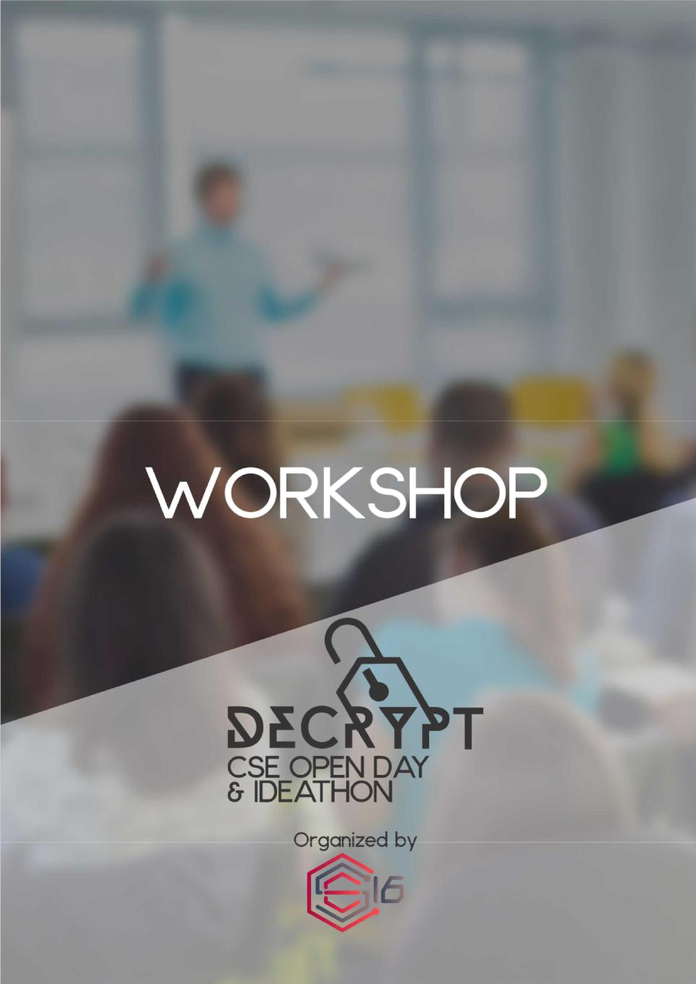
You cannot solve a problem until you ask the right questions…

It does not matter whether you are programming or facing a practical scenario in your day-to-day life; approaching the problem right is a skill you have to master. If you take the first step right, the rest of the journey would be a piece of cake.

There is no need of research and survey to understand that most students find programming hard because they lack the competency of formulating a proper solution upon being confronted with a problem. Thus we, ’16 batch of CSE undergraduates, along with the CSE Open Day, Decrypt, intend to bestow upon the fresh batch of Engineering undergraduates the opportunity of learning several techniques to approach a problem before starting to write the first line of code.

Further, as a part of the workshop, we would be providing insight into the life inside CSE as well as the multitude of career opportunities that are available after graduation as a Computer Science Engineer.
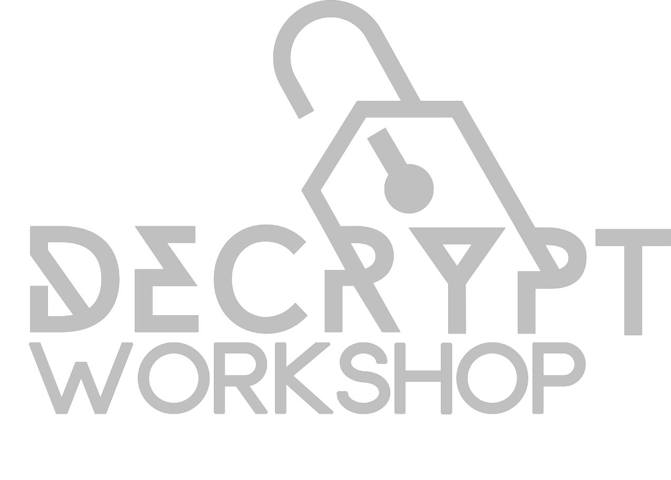

Outline

The workshop would comprise 2 main components as follows:

- The first half would be based on successful approaches to problem solving. The basic knowledge that would be conveyed is how to put together an efficient algorithm for a given problem.

Participants will be divided into 15 groups of 10 members each. In first 15 or 20 minutes there will be giving some idea about flow charts. After that question will be given to the groups and give some time to get an idea to approach the problem. After that facilitator will do the approach of that problem.

- The second half is expected to give an insight about the life at CSE and the opportunities for its graduates as well as undergraduates to take their novel ideas to the world.

Interested students from ’17 batch of undergraduates of University of Moratuwa are welcome to register for the workshop via the official web site http://www.decryptcse.com. Due to the limited amount of space available and the interactive nature of the workshop, only 150 students would be granted admission on a first come first serve basis.
Organizing crew

The workshop is organized parallel to the CSE Open Day and handled by the batch of 2016 of the Department of Computer Science & Engineering with the guidance of academic staff.

Any concern regarding the workshop is to be directed to the chief organizers or batch representatives of ’16 batch.

Osanda Hemachandra
Chief organizer – Workshop
Email: osanda.16@cse.mrt.ac.lk
Mobile: 077 312 9022

Dhananjana Senarathna
Chief organizer – Workshop

Email: sachinthadhananjana.16@cse.mrt.ac.lk
Mobile: 077 760 1323

Harith Sankalpa
Batch representative
Email: harith.sankalpa.16@cse.mrt.ac.lk
Mobile: 071 235 7550

Vinura Perera
Batch Representative
Email: vinuraran.16@cse.mrt.ac.lk
Mobile: 071 475 5134

